(Approx. 601 words)

President’s Message
What is a VPN (Virtual Private Network) and why use one?
By Jeff Wilkinson, President, Sun City Summerlin Computer Club, NV
May 2019 issue, Gigabyte Gazette
www.scs-cc.com
pres.scscc (at) gmail.com

A Virtual Private Network (VPN) is a connection method used to add security and privacy to private and public networks, like Wi-Fi Hotspots and the Internet. Use of a VPN allows for encrypted data transmission and prevents tracking or monitoring by internet service providers, advertisers and people with malicious intent.

A VPN encrypts your data, and your location and connection are unable to be viewed by anyone. You can use a VPN to prevent your personal data, mobile banking and social media activity from being stolen by hackers as you search with an anonymous IP address. A VPN operates as a secure messaging tunnel between your device and destinations you visit on the internet.

Your device connects to a VPN server which can be in the United States, or a foreign country like the United Kingdom, France or Sweden! Your internet traffic passes back and forth through that server. As far as most web sites are concerned you are browsing from that server’s geographical location, not your physical
location.

While a VPN can’t promise total anonymity, it can be very useful for typical users. A VPN also won’t do much to keep advertisers from tracking you online. Remember that the website you visit is aware of what you do on its site and that applies equally to advertisers serving ads on that site. There are browser add-ons like Ghostry, Privacy Badger and HTTPS Everywhere that can help with that issue.

How do you decide which VPN service to use? First, it pays to pay when it comes to choosing a VPN service. Free options exist, but they usually offer a limited amount of bandwidth and or a slower service with limited number of servers. The good news is that perfectly good VPN services cost as little as $5 per month, when purchased in blocks of months. Of course, you want to avoid services that keep logs of your activity, IP addresses, websites you visit or any other details of your activity.

So how do you set up and use the VPN you have chosen? Most have applications you can download to your PC and mobile devices. You should choose a VPN service that has apps for all the devices you use, allows enough simultaneous connections for your devices, has locations in countries of interest to you, has adequate servers and IP addresses and supports your speed needs at a reasonable price. IMPORTANT!

Financial institutions and streaming services like Amazon Prime and Netflix will not work with a VPN since their security depends on verifying their customer.

Many VPN services offer free trials and have frequent sales offerings to new customers. Take advantage of the free trial to put the VPN through its paces.

I have been using IPVanish (https://www.ipvanish.com) for a little over a year now and it works perfectly on all my devices. Of course, all VPNs will have some speed penalty depending on the VPN server you use. I haven’t had any problems.

Here’s an example of an experience I had using a VPN. While surfing a web page, an obnoxious ad for health insurance seemed to consume a large amount of a page I was viewing. I wondered, if I were surfing the same page from Boston, would that same ad come up. So, I used my VPN to surf the same page as if I was located in Boston. Sure enough, same obnoxious ad. I then wondered whether that ad would appear if I were in Helsinki, Finland! Using my VPN I changed cities to Helsinki, Finland.
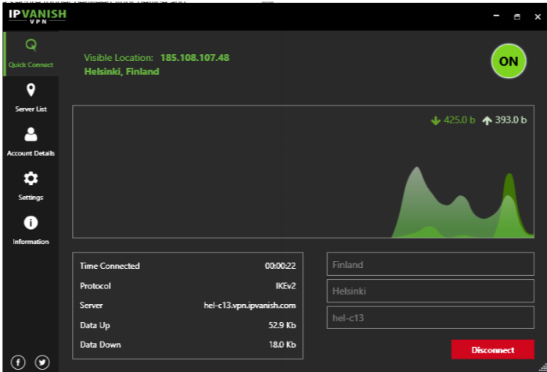
This time, that ad did not appear; but a smaller ad appeared for a different product.
This is just a quick overview of VPN’s to give an idea of what they are and why someone would use one.

